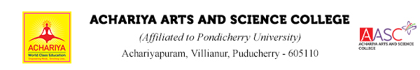
ABOUT THE DEPARTMENT
The Department of Corporate Secretaryship, founded in 2004, aims toaddress the evolving needs of businesses and industries in the fields ofManagement, Accountancy, Costing, Finance, and CompanySecretaryship. While professional courses such as ICAI and ICWA caterto these domains, there is a growing demand for skilled professionals tosupport companies on a daily basis. This necessitates not onlyincreasing the number of qualified professionals but also developing anew cadre of experts to assist in these critical areas.

Vision
Our vision is to be a center of excellence in Corporate Secretaryship education, empowering students to become competent professionals in corporate governance, company law, and secretarial practices. We aim to nurture ethical leaders and dynamic entrepreneurs who drive organizational growth and societal transformation. Our goal is to develop skilled professionals equipped with the knowledge, values, and practical experience for success in the corporate and legal sectors.

Mission
- To provide high-quality, accessible education in Corporate Secretaryship, aligned with global academic standards and industry needs.
- To establish a solid foundation in company law, corporate governance, secretarial practices, and compliance, preparing students for the complexities of the corporate world.
- To foster critical thinking, analytical abilities, and sound decision-making skills relevant to corporate governance and business operations.
- To promote professional ethics, integrity, and accountability, ensuring that students uphold high standards in their professional careers.
- To develop entrepreneurial spirit and leadership qualities through value-based education and practical exposure to real-world corporate scenarios.
- To engage students in research, internships, and industry interactions, ensuring that they are well-prepared for diverse career opportunities in corporate, legal, and financial sectors.
- To equip students with the skills and training necessary to carry out action-oriented research in the corporate sector, enhancing their employability and leadership potential.

DEPARTMENT ACTIVITY
DEPARTMENT OF CORPORATE SECRETARYSHIP – ODD SEMESTER EVENT DOCUMENT 2025-26
S.NO | NAME OF THE EVENT | DATE
1 | GUEST LECTURE | 18.7.2025
2 | ORIENTATION PROGRAM | 19.8.2025
3 | INDUSTRIAL VISIT | 12.9.2025
4 | ORIENTATION PROGRAM | 11.9.2025
5 | CLUB INAUGURATION | 16.9.2025
6 | GUEST LECTURE | 29.9.2025

GUEST LECTURE
“THE ROLE OF MARKETING IN BUSINESS STRATEGY”
The Department of Corporate Secretaryship successfully organized a Guest Lecture Program on “The Role of Marketing in Business Strategy” on July 18, 2025. The guest lecture was delivered by Mr. S. J. Vigneshwaran , Assistant Professor, Department of Business Administration, Ayya Nadar Janaki Ammal College, Sivakasi. With his profound expertise in marketing, he emphasized the strategic importance of marketing in today’s business environment. He elaborated on various approaches and shared real-time examples to highlight marketing’s pivotal role in driving business success.
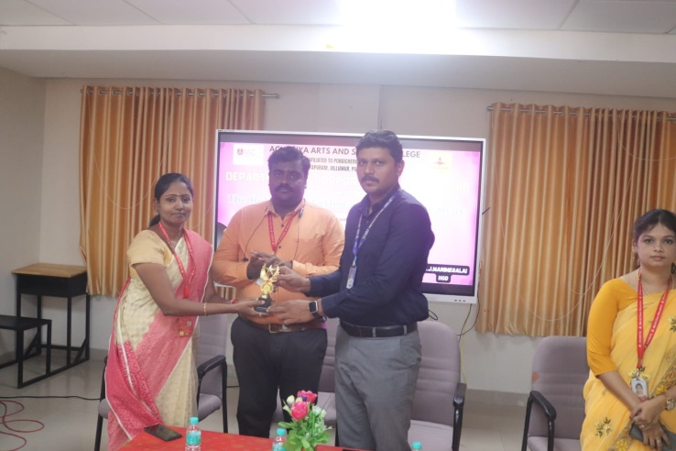
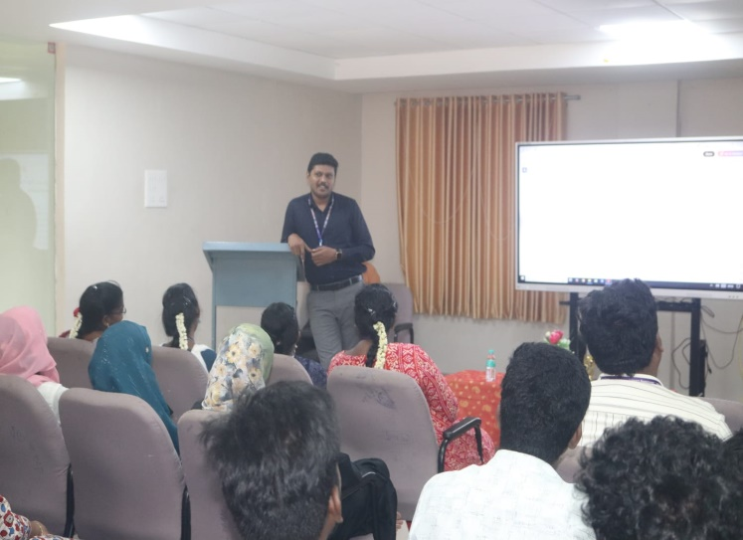
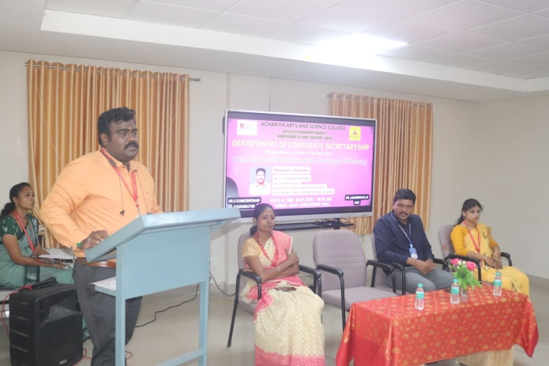

ORIENTATION PROGRAM-
ENTREPRENEURSHIP OUTREACH PROGRAM”
The Department of Corporate Secretaryship successfully organized an Orientation Program on “Entrepreneurship Outreach Program” on August 19, 2025. The orientation program was delivered by Mr. Andrew Surjith Ronald, Project Head, SPARC, who elaborated on the role of entrepreneurs, the challenges they face in the current scenario, and emphasized the significance of the incubation hub as a platform for young budding entrepreneurs to present and develop innovative ideas.
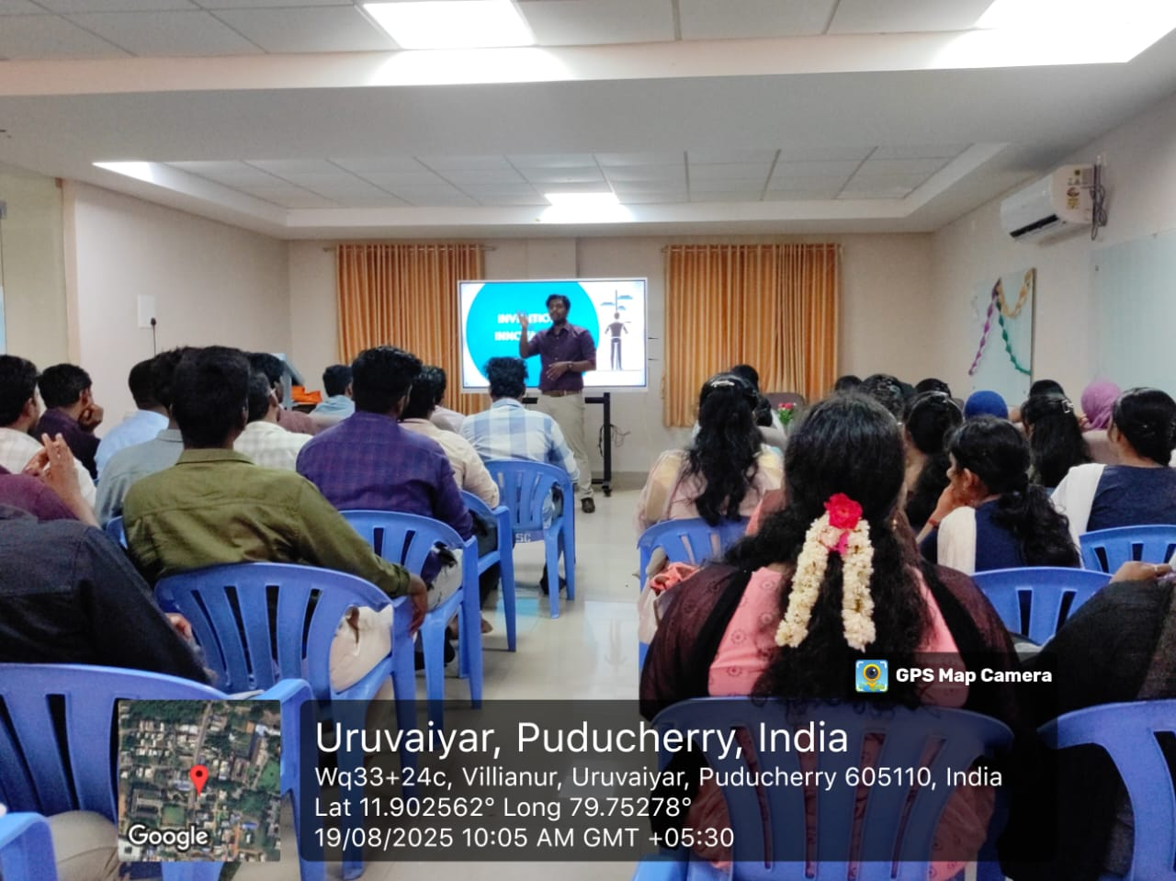

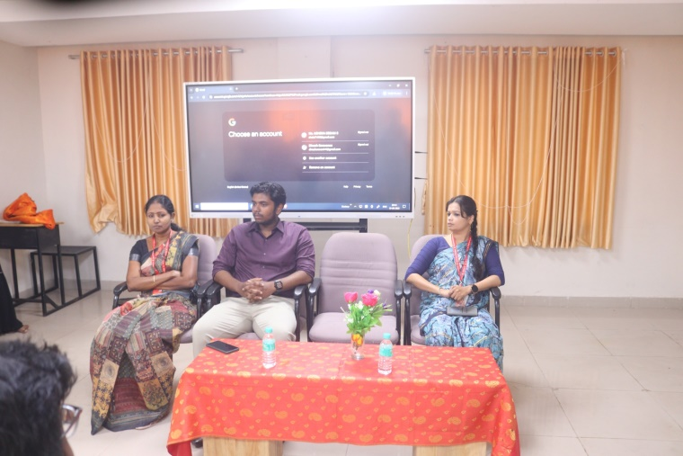

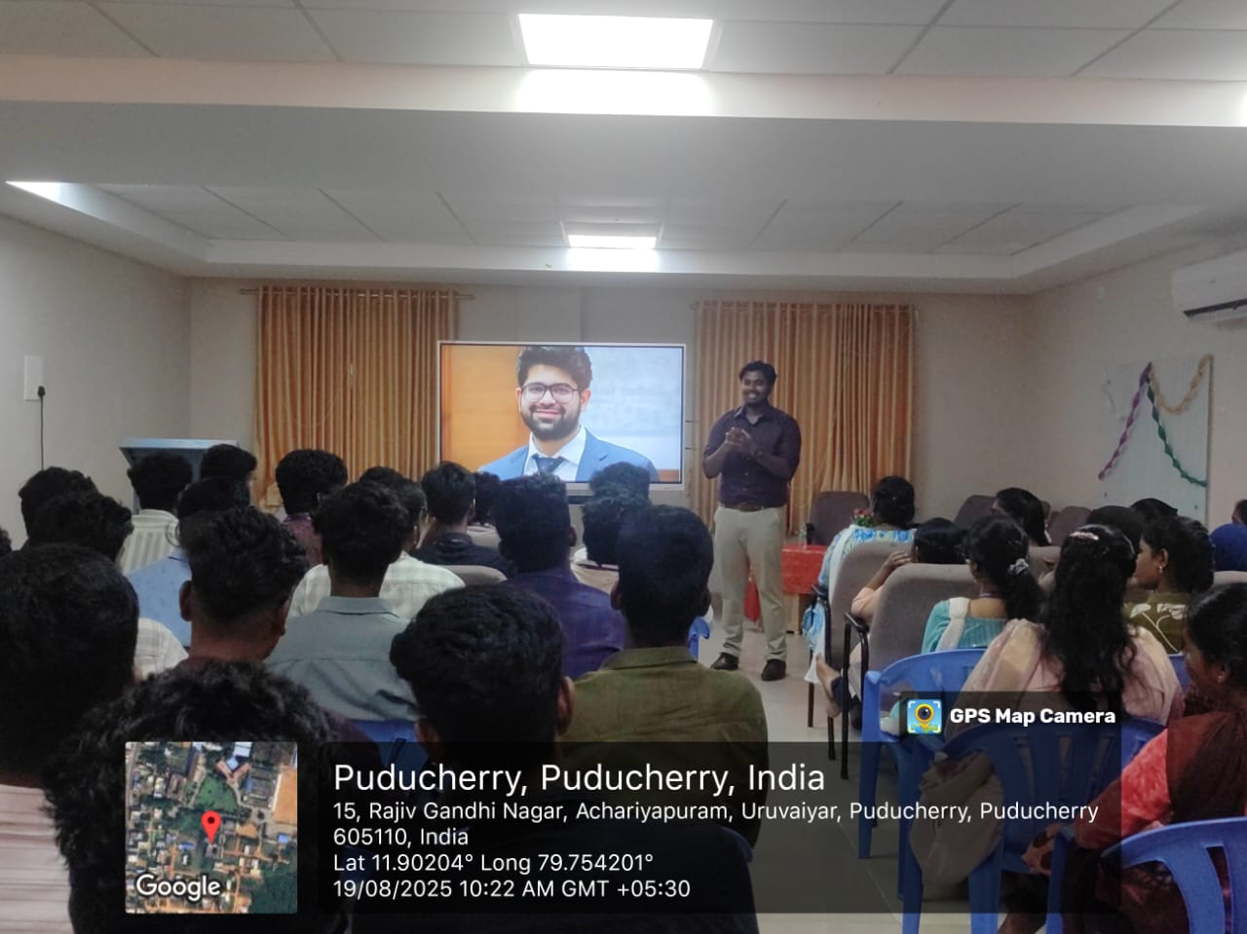

INDUSTRIAL VISIT
The Departments of Corporate Secretaryship organized an Academic Field Visit on 12th September 2025 to prominent historical and cultural sites in Tamil Nadu. The objective of the visit was to provide students with experiential learning beyond the classroom and to enhance their understanding of history, culture, and heritage.
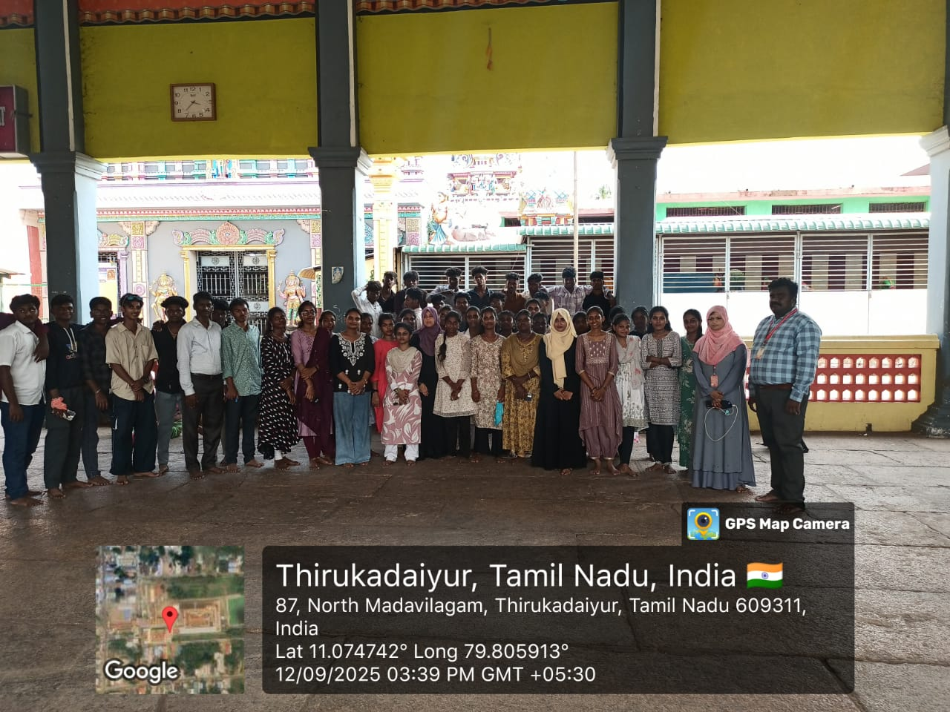

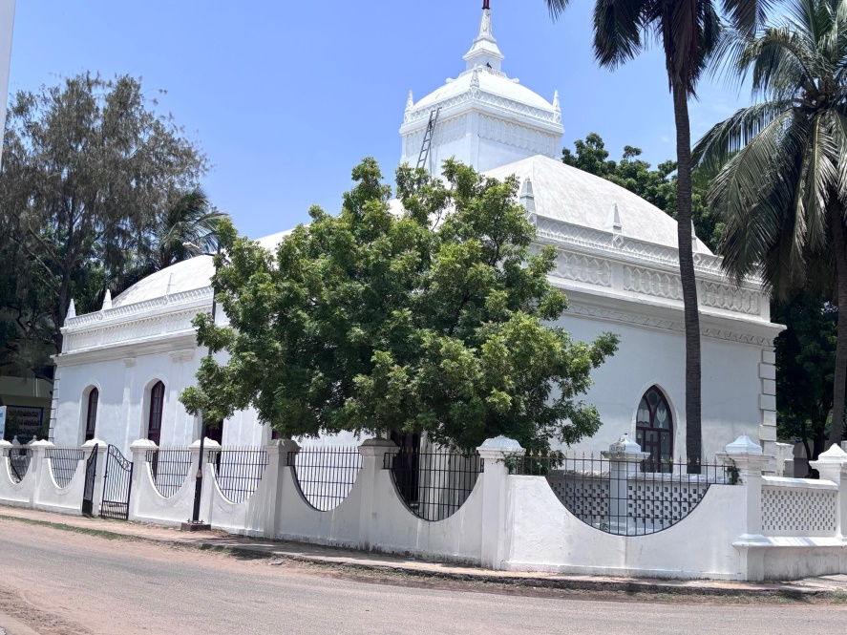

ORIENTATION PROGRAM-ACS

The Orientation Programme of *ACS (Associate Company Secretaryship) for our First-Year students was successfully held on 11.09.2025.The session featured Mrs. Chitra, ACS, from the Institute of Company Secretaries of India, as the esteemed Chief Guest.
The session, titled “ ACS Orientation – Registration Process, Benefits, Subjects Involved, and Tips for Success,” resonated deeply with the students and sparked meaningful engagement and interest
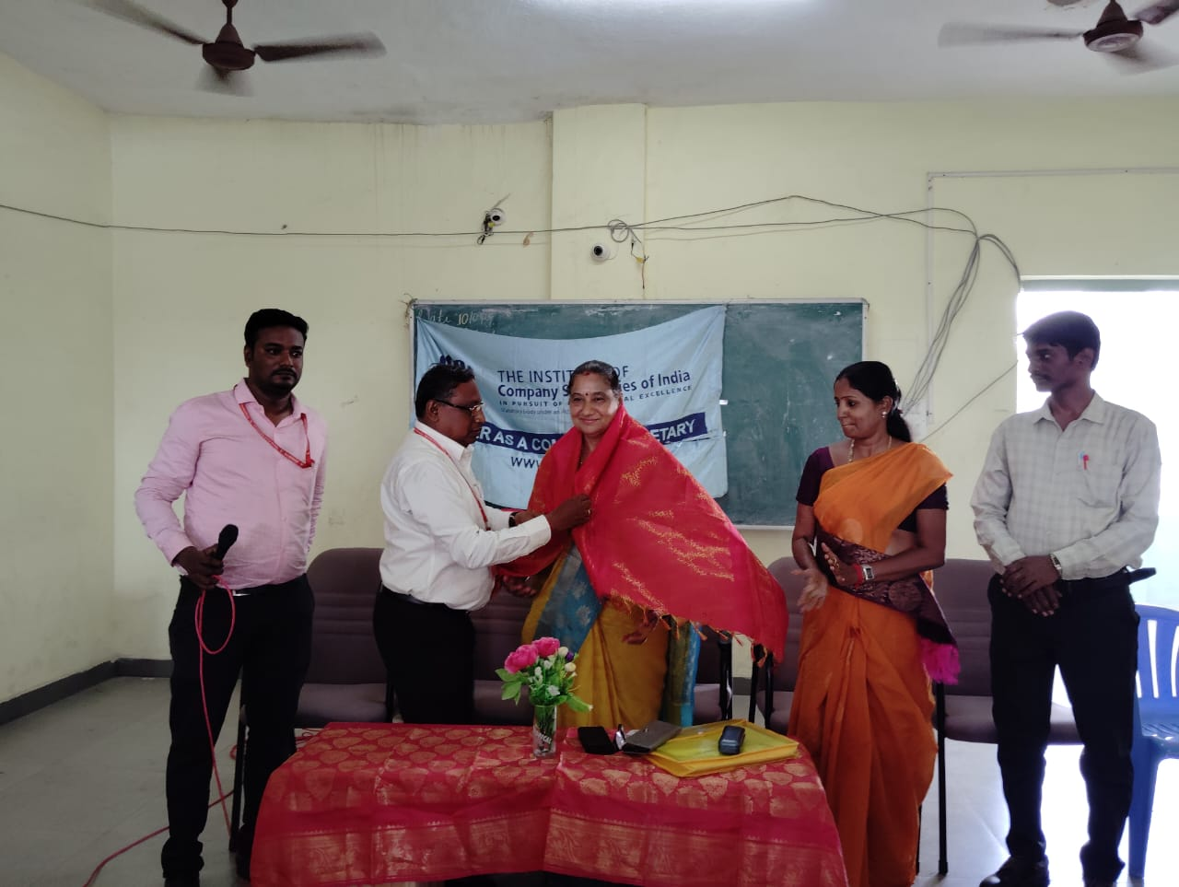

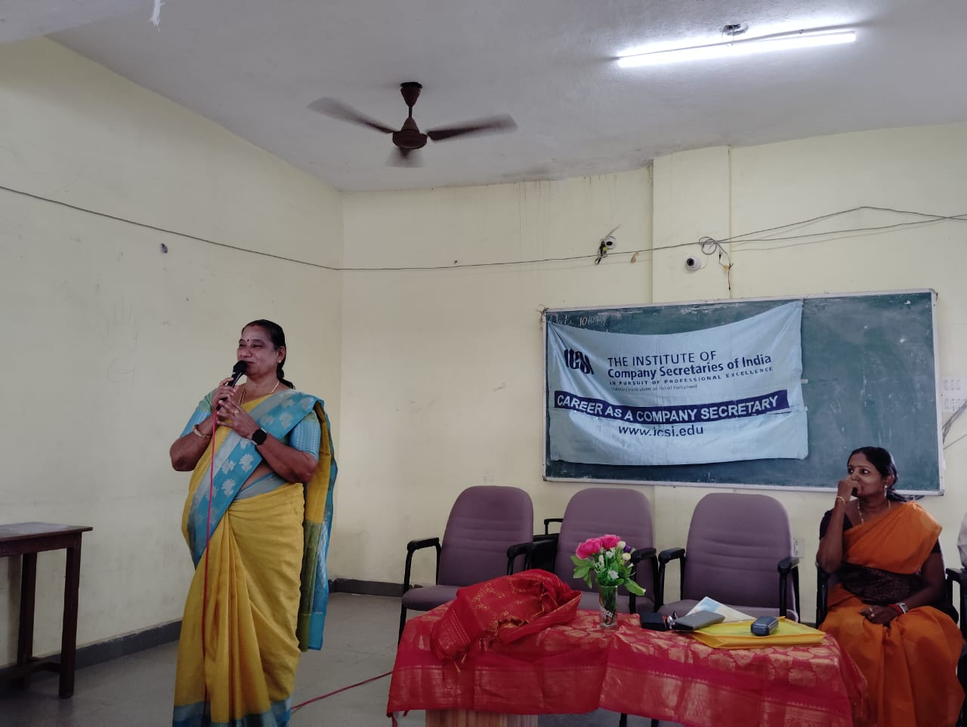

CLUB INAUGURATION
The Department of Commerce and Management inaugurated the Achariya Bulls and Bears Club (ABBC) on September 16th 2025.
The highlight of the event was the special session by Dr. T. Vigneshwaran, CMA, Former Vice President of ICMA, Pondicherry chapter, who delivered an insightful talk on Finance and Trade. His session enriched students with valuable knowledge on market dynamics, trading practices, and professional opportunities in commerce and management.
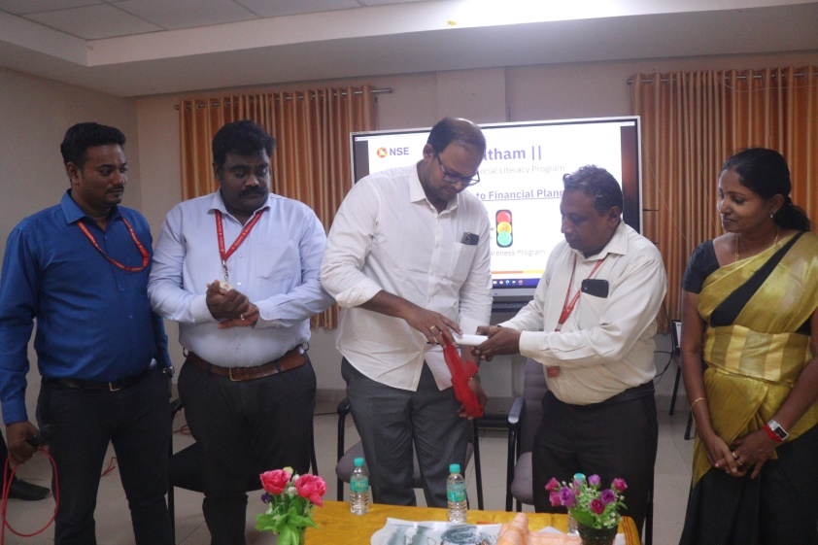

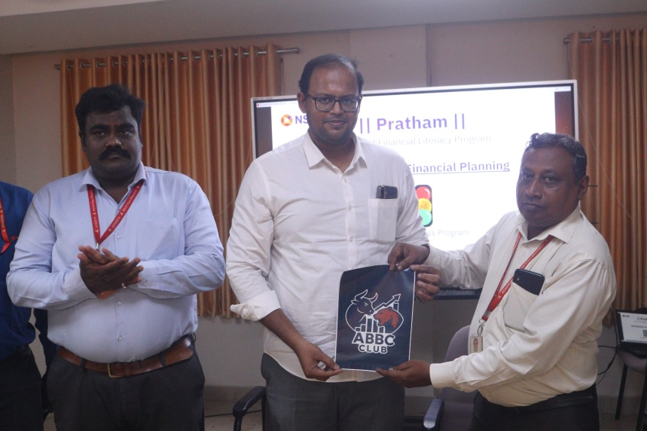

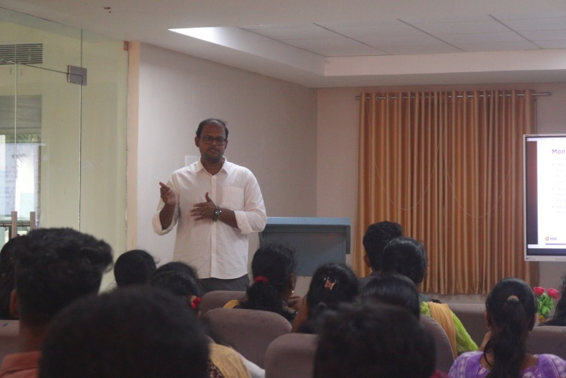

GUEST LECTURE
We are delighted to share that the Department of Corporate Secretaryship, Achariya Arts and Science College, organized a Guest Lecture on the topic “College to Corporate – Business Models” on 29th September 2025 (Monday).
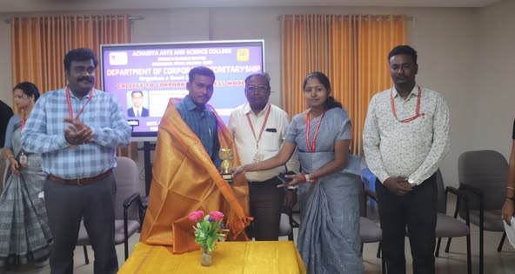
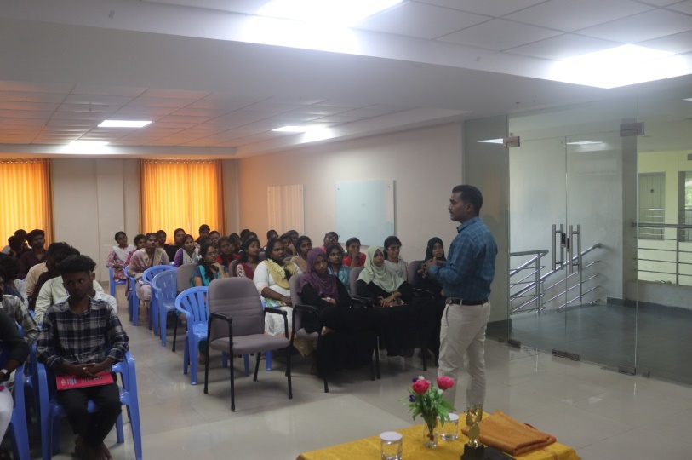

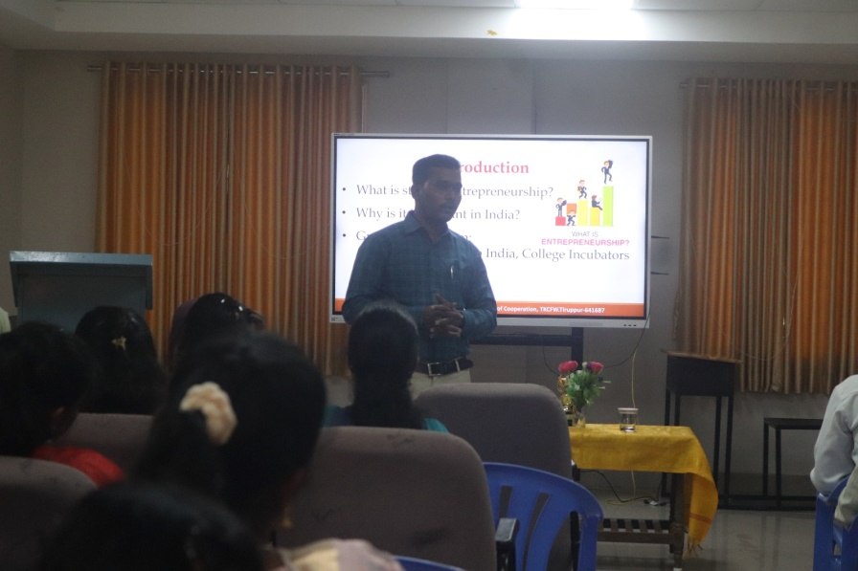

MARATHON
R. Mukesh of I B.Com (CS) represented our college and participated in the “VASCO PONDY RUN 5K 3.0 – SAY NO TO DRUGS” awareness marathon competition (Men & Women), organized by VASCO Organization on 23rd November 2025 at Mahatma Gandhi Statue, Beach Road, Puducherry.
We are proud to announce that R. Mukesh secured the 5th place overall in the competition and received a cash award, medal, and certificate from the Chief Guest, Mr. Charles Martin.

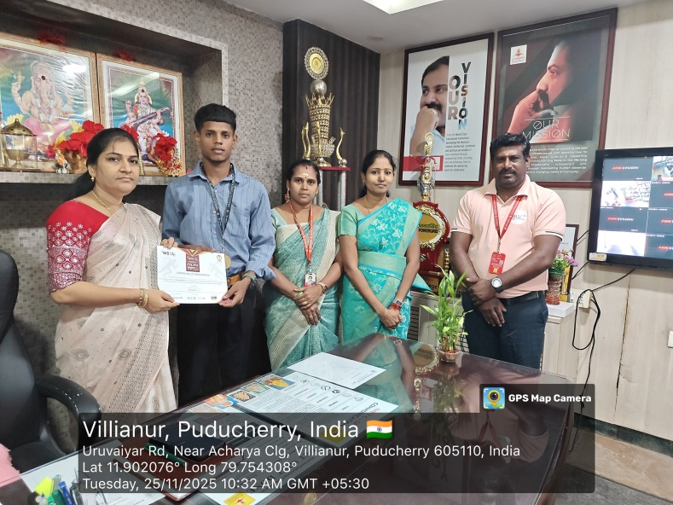

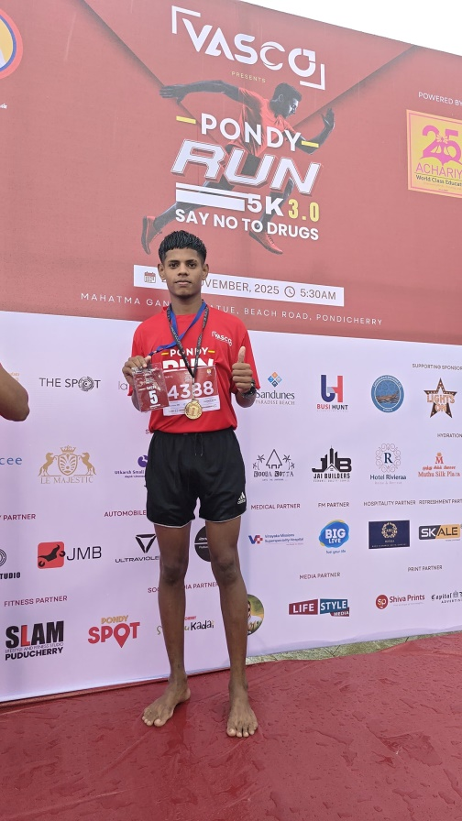

MUNCHVILLE-2K25
We are delighted to share that our B.Com Corporate Secretaryship students actively participated in MUNCHVILLE–2K25, held on 25th November 2025 (Tuesday) at Achariya Arts and Science College, Puducherry.
Our students showcased exceptional enthusiasm, creativity, and entrepreneurial spirit by managing various stalls under unique brand names such as SR Accessories, Bakery Payaluga, Bites and Blast, and Heist Thattuvadai.

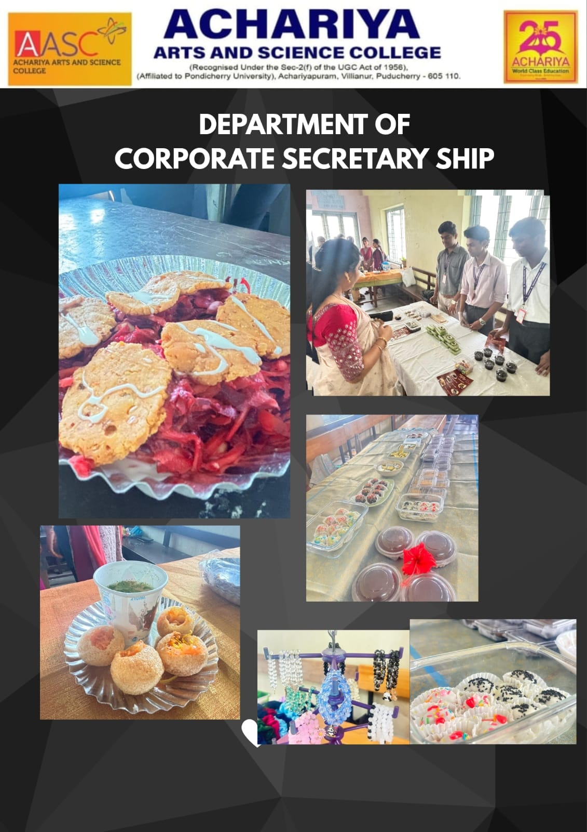

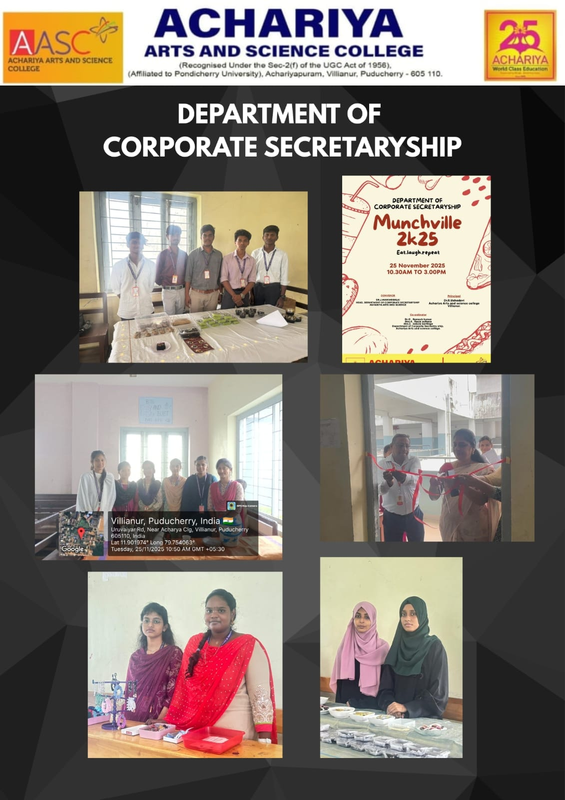
INDIAN ART CONTEST

Subiksha from ii B.COM (CS) have actively participated in Drawing competition organised by Indian Art Contest on 12.11.2025.
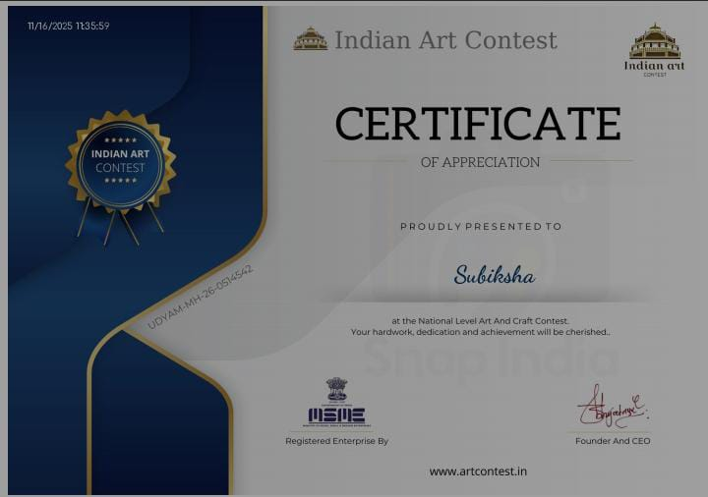

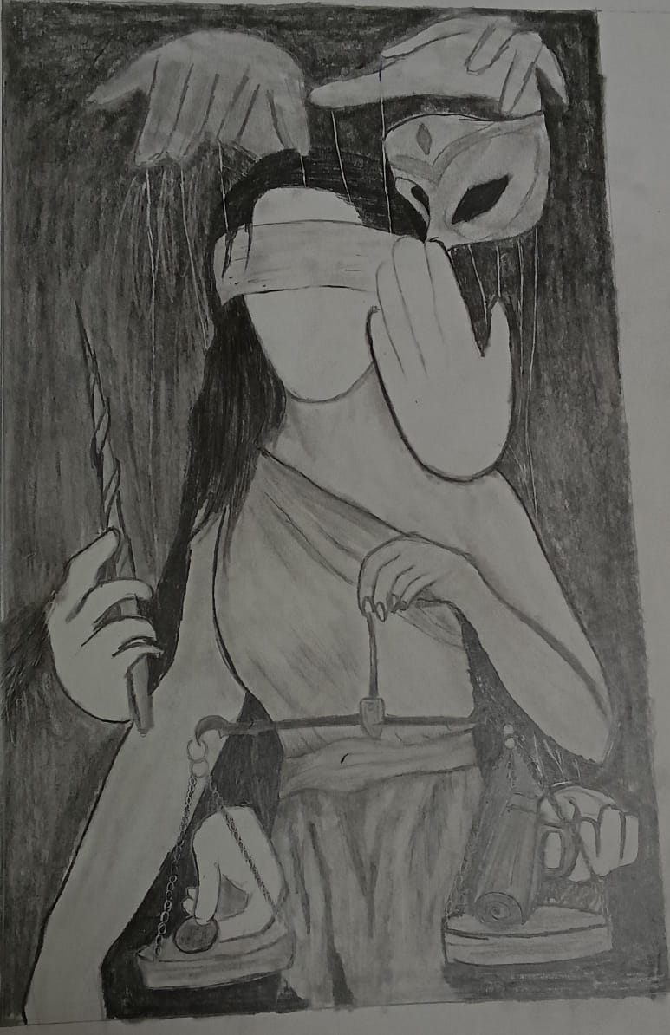

EDUTAINMENT
We are delighted to share that our B.Com Corporate Secretaryship students actively participated in a Poster Presentation held on 11th November 2025 (Tuesday) at Achariya Arts and Science College, Puducherry.
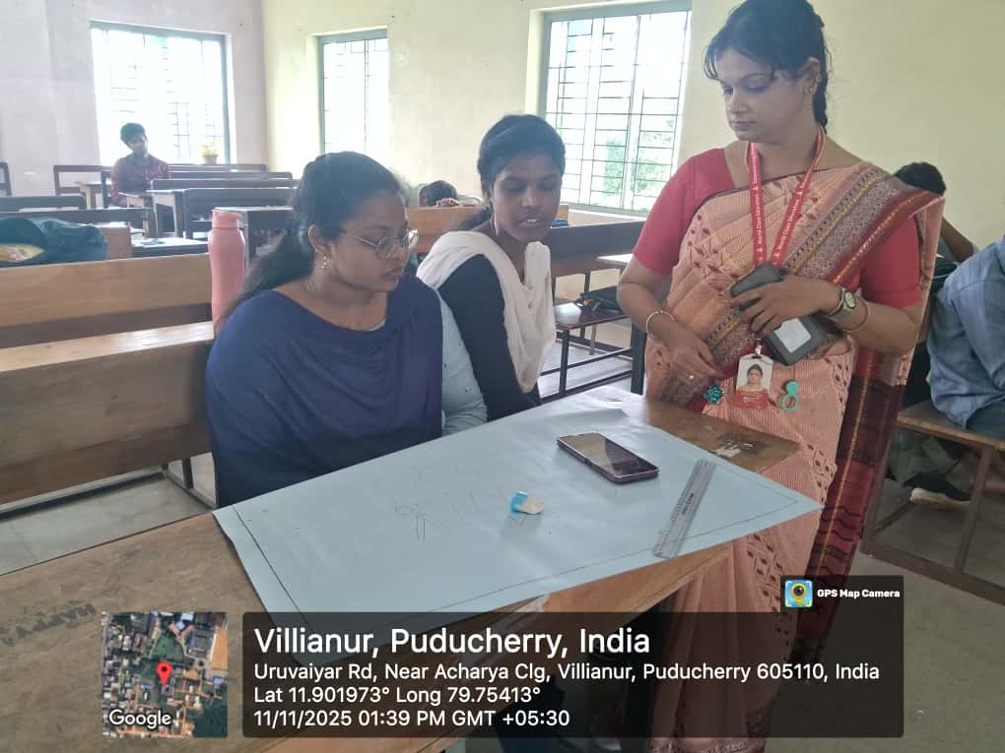
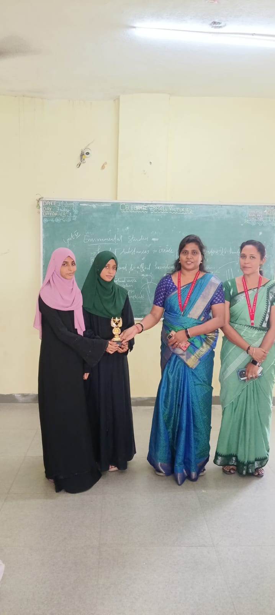
Our students showcased remarkable enthusiasm and creativity through poster presentations on various topics — I Year: Creation of Logo, II Year: Pen Theory, and III Year: E-Commerce . The event provided them with valuable practical exposure and an excellent platform to present their innovative ideas, thoughts, and perspectives. This program was coordinated by Mrs. Razia Sultana. A , whose dedicated efforts contributed to the successful organization of the event.
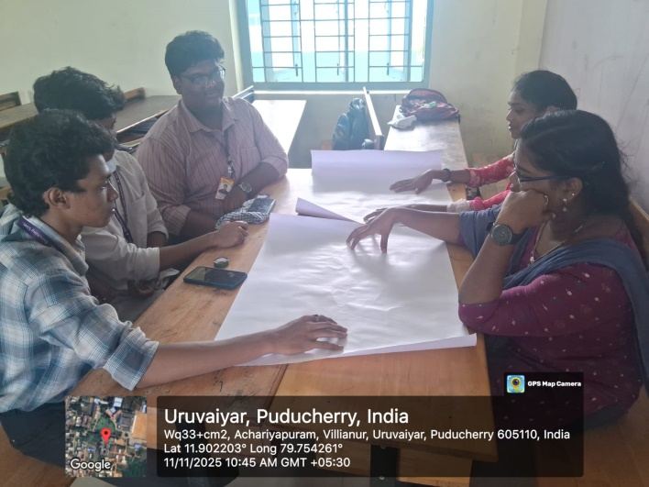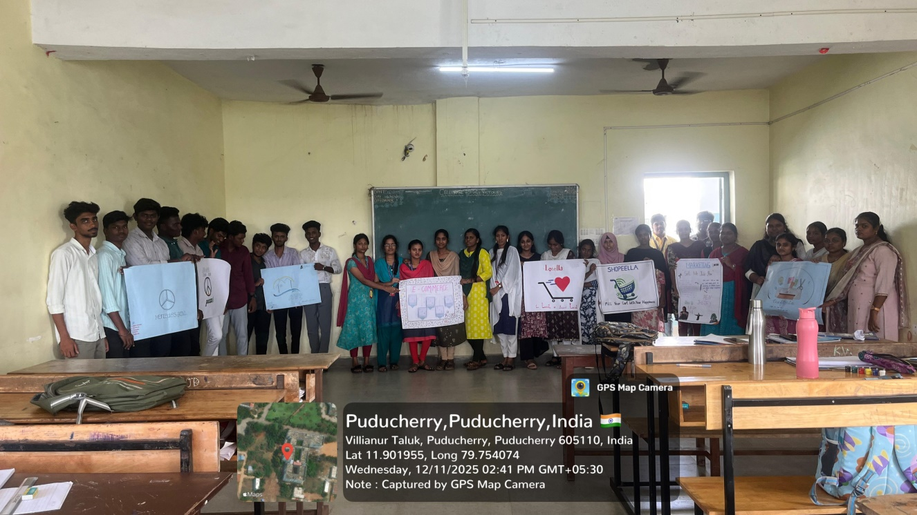

G-TALK
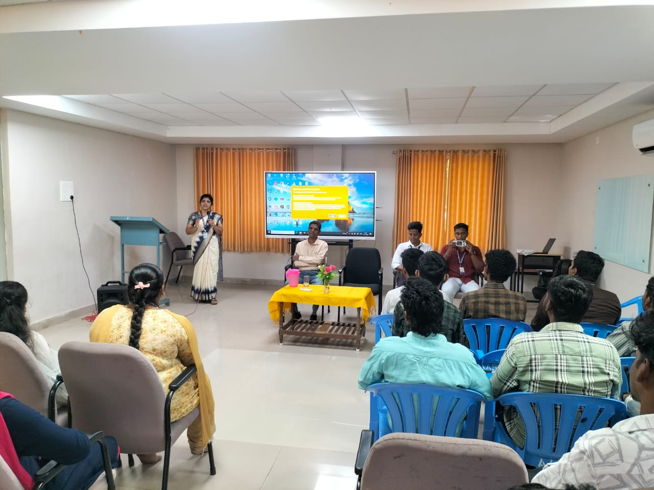
Our department students actively participated in insightful seminar on “TALLY PRIME 2.0” on 11th November 2025 in collaboration with GTech Computer Education, The seminar commenced with a welcome address by Mr. A. Kesavan, Assistant Professor, Department of Commerce. This was followed by a guest session by Mrs. Saraswathi from GTech Computer Education, who gave an in-depth explanation of Tally Prime 2.0 and its integration with GST.

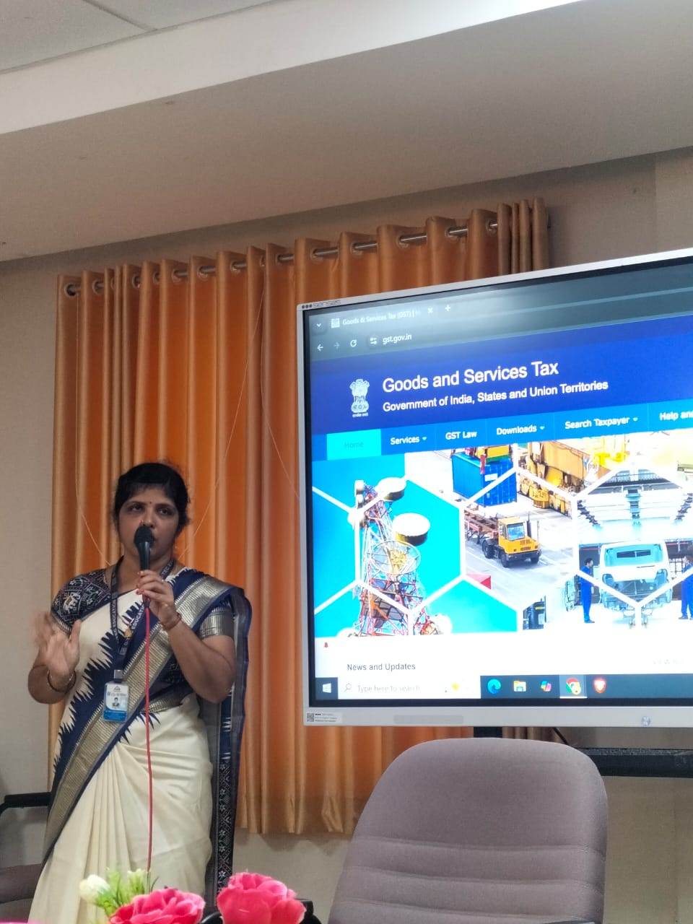

SPORTS ACTIVITY
1. We are delighted to share that our students actively participated in the 100th Year of Indian Hockey Centenary Celebration Invitation Tournament organized by the Le Hockey Puducherry Association in collaboration with Achariya College of Engineering and Technology, Villianur.
The tournament was held on 7th November 2025 (Friday) at the ACET Campus, Villianur, Puducherry.
Our college students participated enthusiastically in the competition and secured the Runner-Up position in the men Category and the Runner-Up position in the Men’s Category.
Our students III B.com CS keerthivasan,Anburasu,Aakash,Ranjith ,Yogindharan,Sivabalan,Krishna kumar and from II b.com Cs-Kanishkar,Kajone

2. We are delighted to share that our student SUSHMITHA from I B.com CS actively participated and winner in the GenNxt-ROTO SPORTS State Level Inter-Collegiate Throw Ball Women’s Tournament – 2025, held on 10th October 2025 (Friday). The event was organized by the Rotary Club of Pondicherry Marina in collaboration with Pondicherry University Community College, Lawspet, Puducherry.
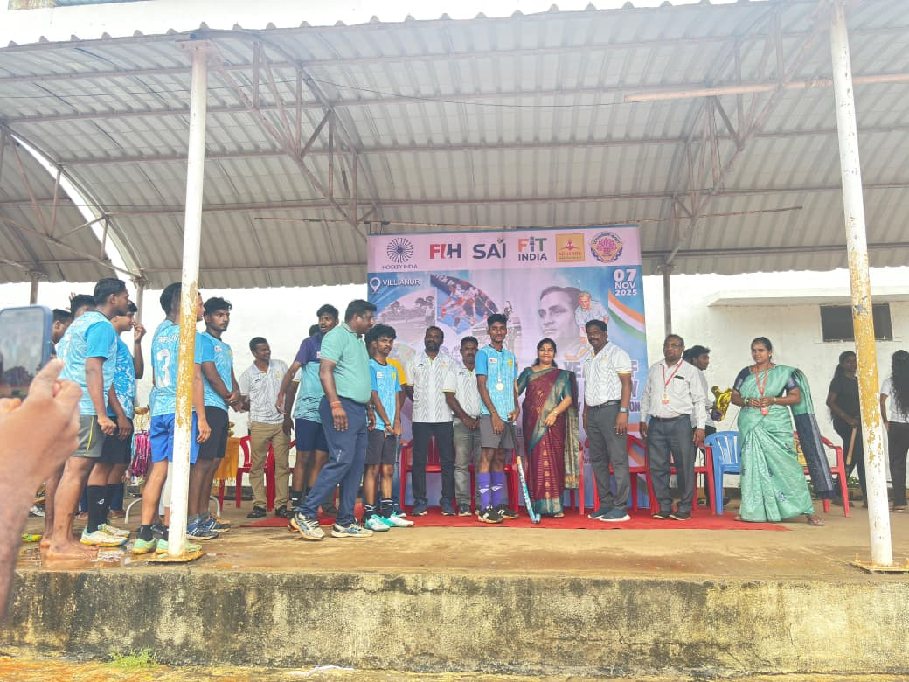

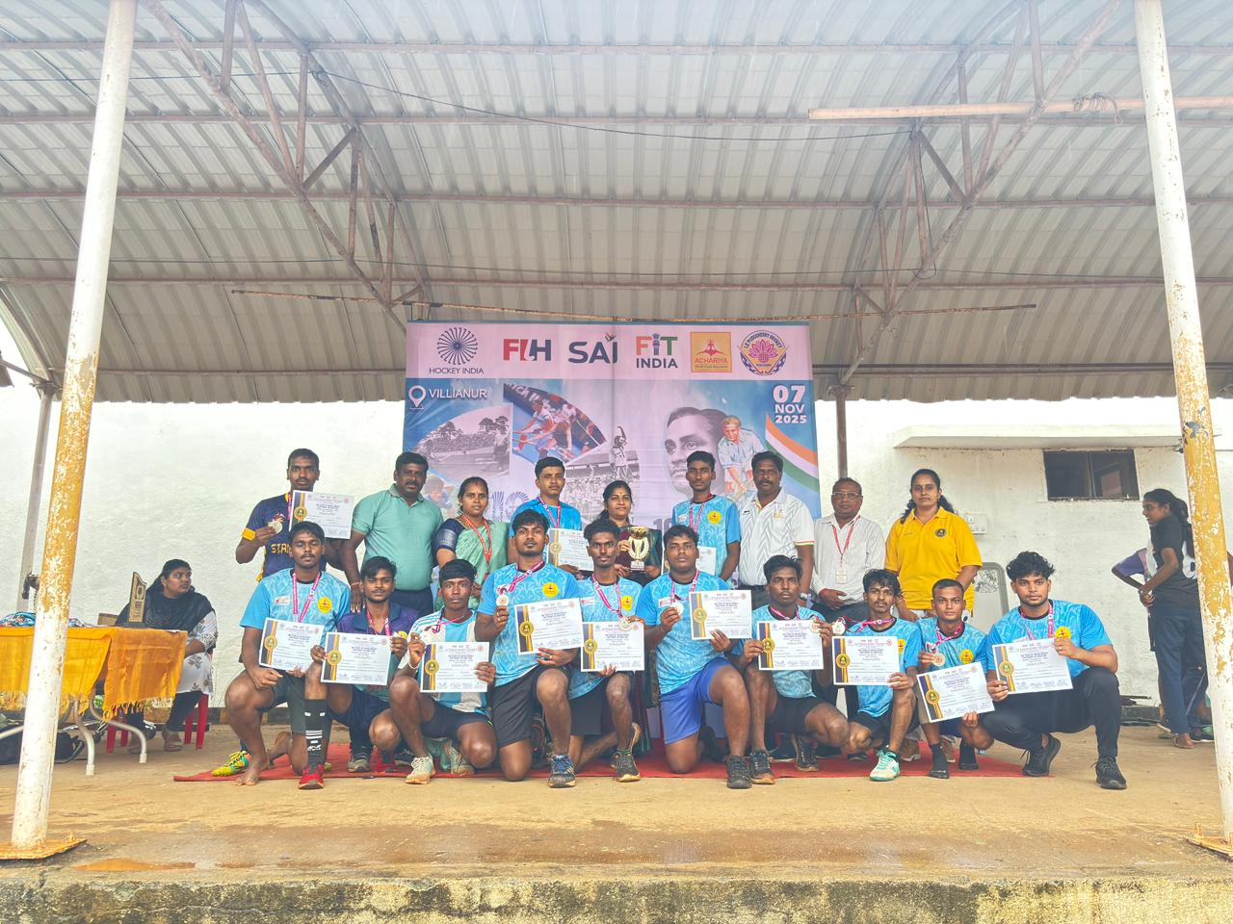

ACADEMIC REVIEW MEETING
The Department of Corporate Secretaryship of Achariya Arts and Science College conducted an Academic Review Meeting on 26.11.2025 from 2:00 p.m. to 4:00 p.m. in the Auditorium, with Mr. Jayasurya Janakiraman, Proprietor of Rajagopal Iyer & Son, as the Alumni Invitee. 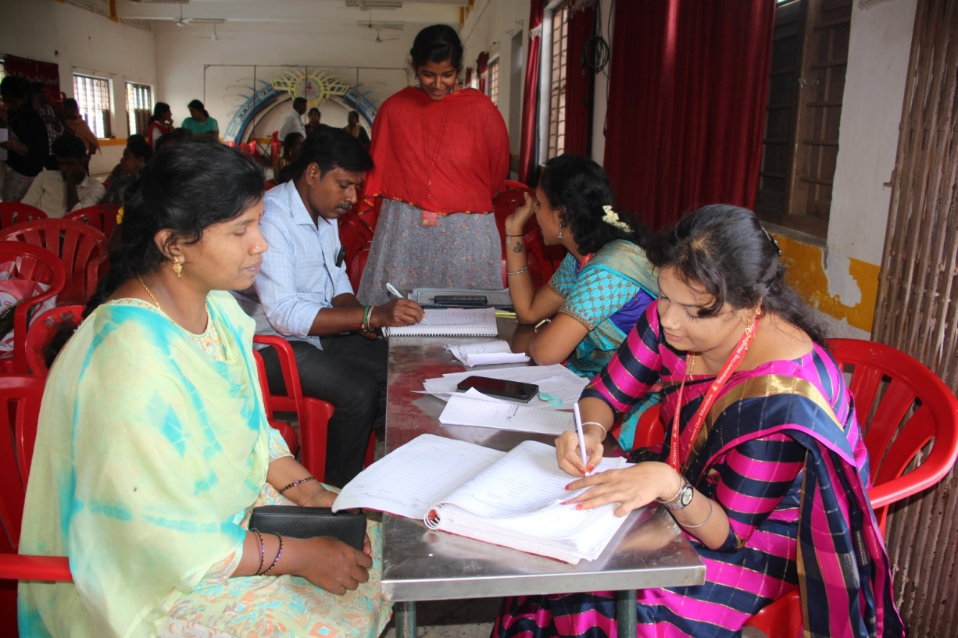
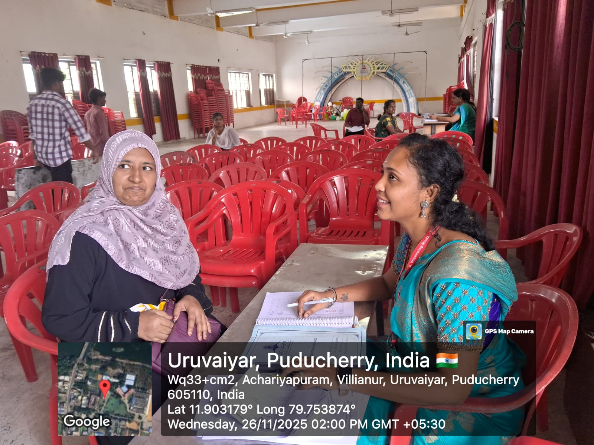

STUDENTS ACHIEVEMENT -ACS
The Department of Commerce proudly says that V. SAI POOJA from I B.com CS has cleared the entrance test in ACS in 2024 on 18.11.2024
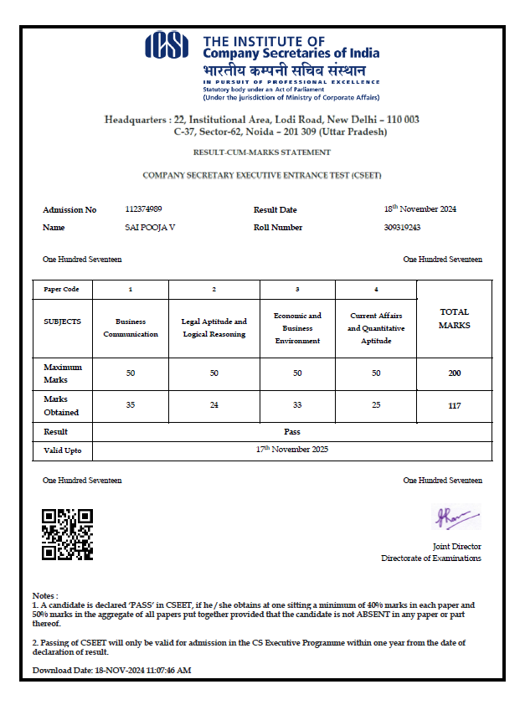
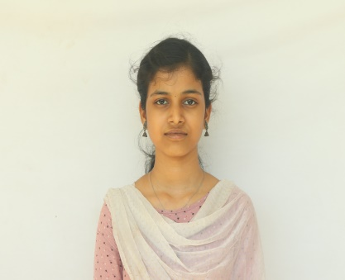

SPORTS ACHIEVEMENTS:
The Department of Commerce is delighted to share that our students, P. Keerthivasan (II B.Com CS) and T. Roshan (II B.Com), will be representing the Pondicherry University Men's Hockey Team in the South Zone Inter-University Hockey Tournament, organized by SRM University, Kattankulathur, Chennai, from January 3rd to 7th, 2025.
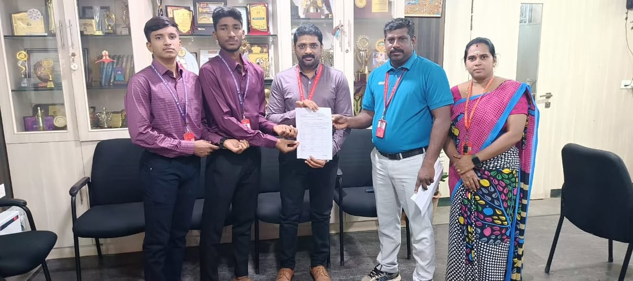
The Department of Commerce is proud to announce that R. Jashwanth Shreeram of III B.Com CS has been recognized as the Top Scorer and Best Batter across India in the BCCI U-23 Multi-Day Col. C.K. Nayudu Trophy for the 2024-2025 season.
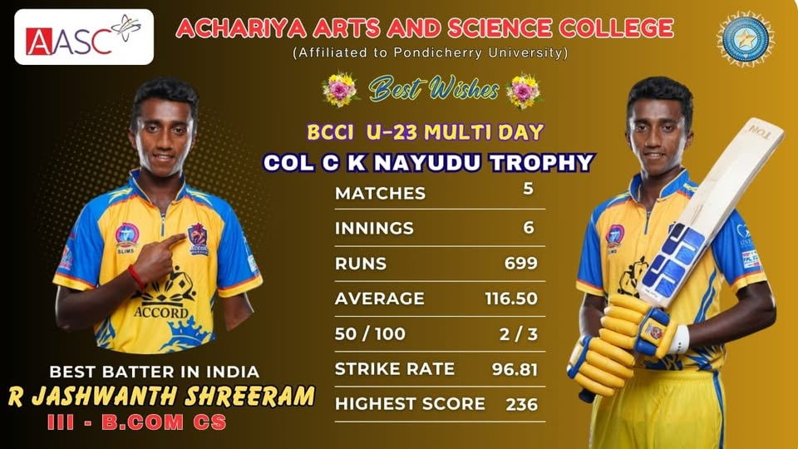

DEPARTMENT OF CORPORATE SECRETARYSHIP – EVEN SEMESTER EVENT DOCUMENT 2025-26
S.NO | NAME OF THE EVENT | DATE
1 | GUEST LECTURE | 13.2.2025
2 | ALL INDIA TALLY EXAM | 18.2.2025
2 | PONDICHERRY UNIVERSITY-GLOBIZZ | 19.2.2025 to 21.2.2025
3 | ST.JOSEPH ARTS AND SCIENCE COLLEGE | 27.2.2024
4 | ST.ANN’S COLLEGE OF ARTS AND SCIENCE | 28.2.2025
5 | ACHARIYA BUSINESS LEAGUE | 26.2.2025
6 | SARADHA GANGADHARAN COLLEGE | 5.3.2025
7 | E S ARTS AND SCIENCE COLLEGE | 5.3.2025
8 | INDUSTRIAL VISIT | 2.4.2025 TO 5.4.2025
9 | SARADHA GANGADHARAN COLLEGE | 30.4.2025
10 | IDHAYA COLLEGE | 24.4.2025
11 | IDHAYA COLLEGE | 3.5.2025
12 | SARADHA GANGADHARAN COLLEGE | 6.5.2025
13 | NATIONAL INSITUTE OF TECHNOLOGY-KARAIKAL | 5.8.2024
14 | MANAKULA VINAYAR INSITUTE OF TECHNOLOGY | 25.3.2025

GUEST LECTURE
We are delighted to share that the Department of Corporate Secretaryship has successfully organized a Guest Lecture on "Women Empowerment" on February 13th, 2025.
The insightful Guest Lecture was delivered by M. Shanmugam (M.A., LLB, D.C.M., Advocate, practicing in District Court and actively engaged in social activities) and T. Lavanya (B.E., Master of Law, Advocate practicing in High Court and District Court). The session provided valuable insights into laws and legal procedures concerning both women and men, along with guidance on overcoming challenges in the current socio-legal landscape.
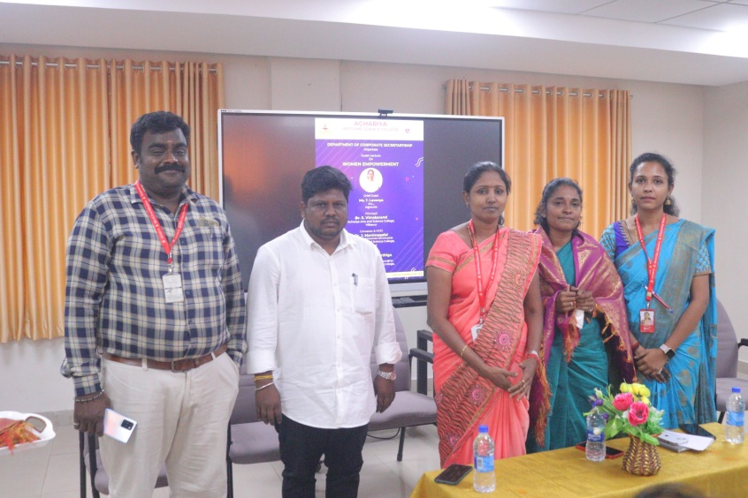

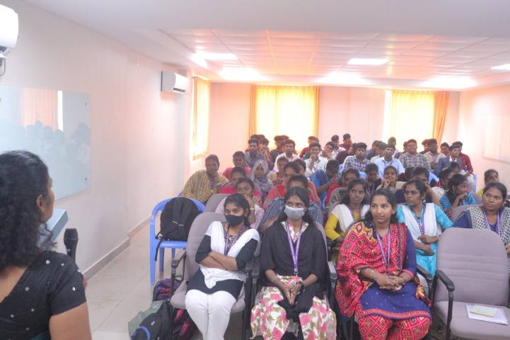

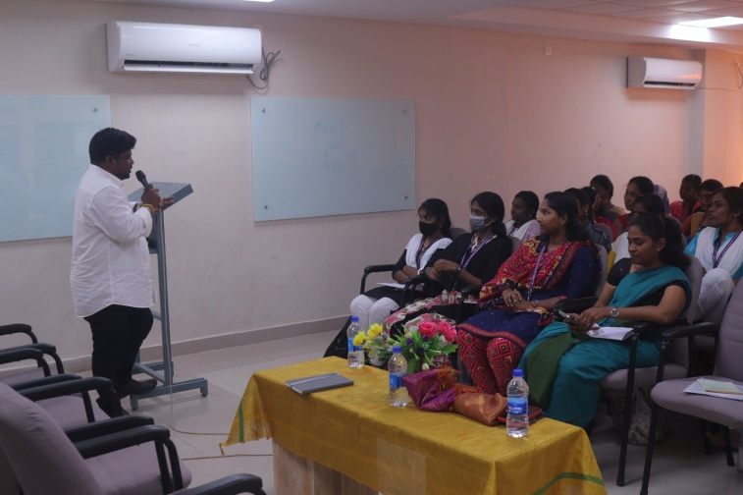

ALL INDIA TALLY EXAM
The Department of Corporate Secretaryship successfully participated in a State-Level Tally Competitive Exam, in collaboration with G-Tech Computer Education, on February 18, 2025.
A total of 36 students participated in this insightful exam, which focused on assessing their understanding of fundamental Tally concepts.
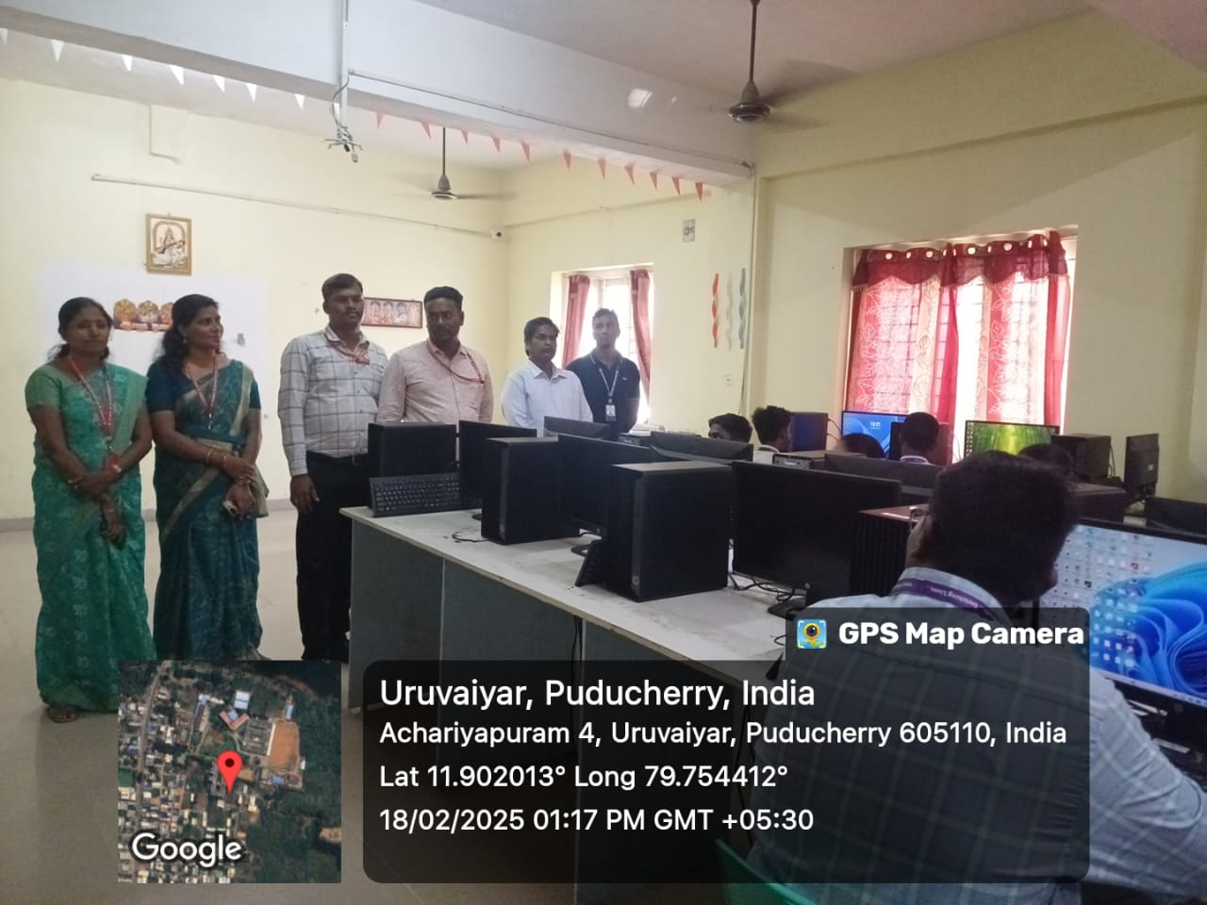

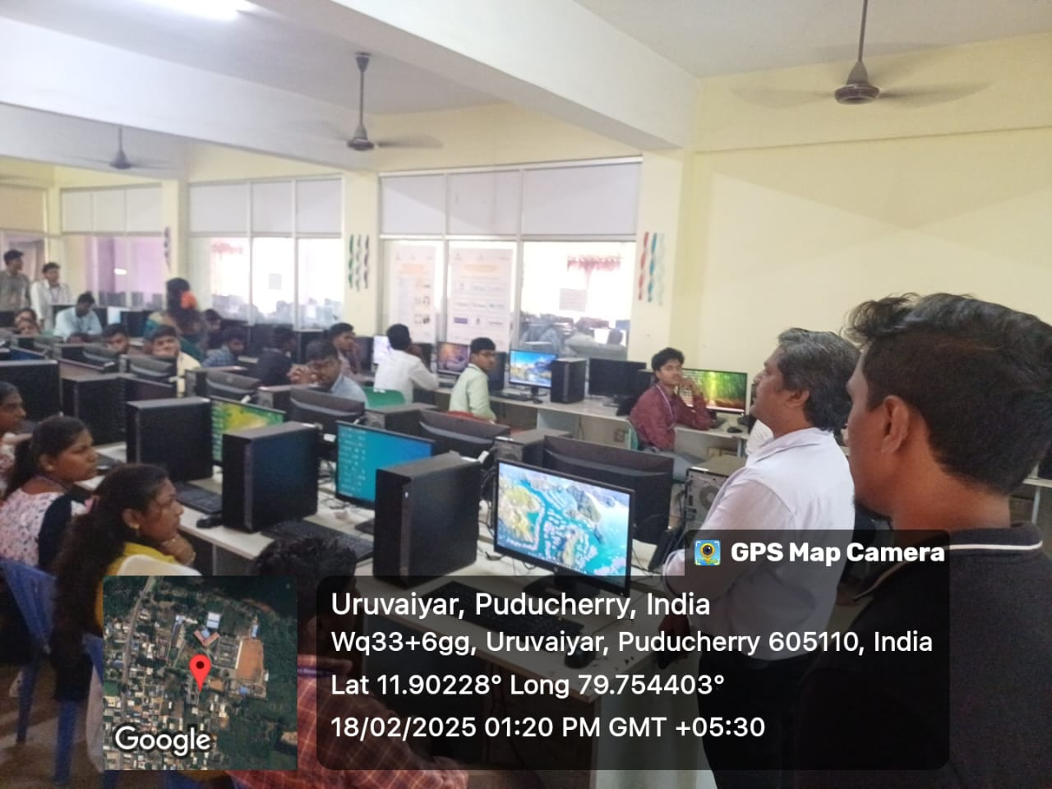

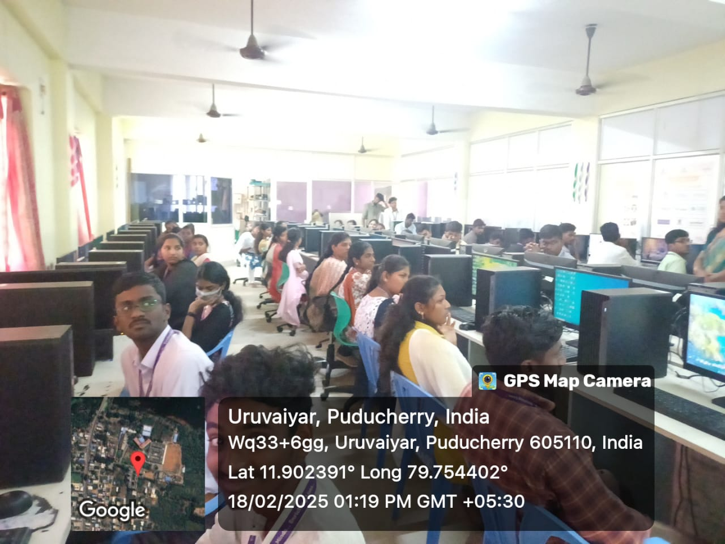

PONDICHERRY UNIVERSITY-GLOBIZZ
We are delighted to share that on Friday, February 21st, 2025, our Corporate Secretaryship students enthusiastically participated in GLOBIZZ-2K25, organized by Pondicherry University. We are proud of their active involvement and accomplishments in the events.
Winner of the event: 1st Prize (Wings Of Lens): C.Krishna Prakash of I B.Com CS.
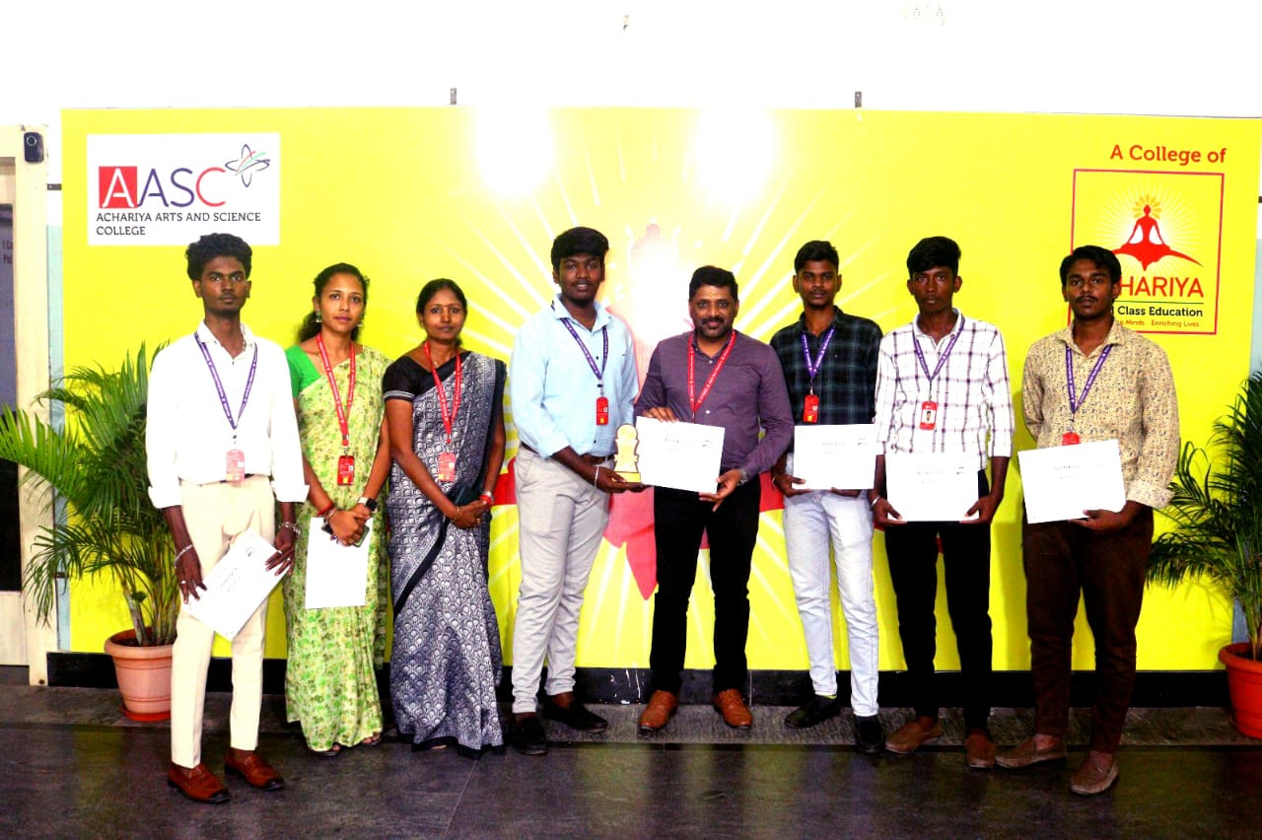

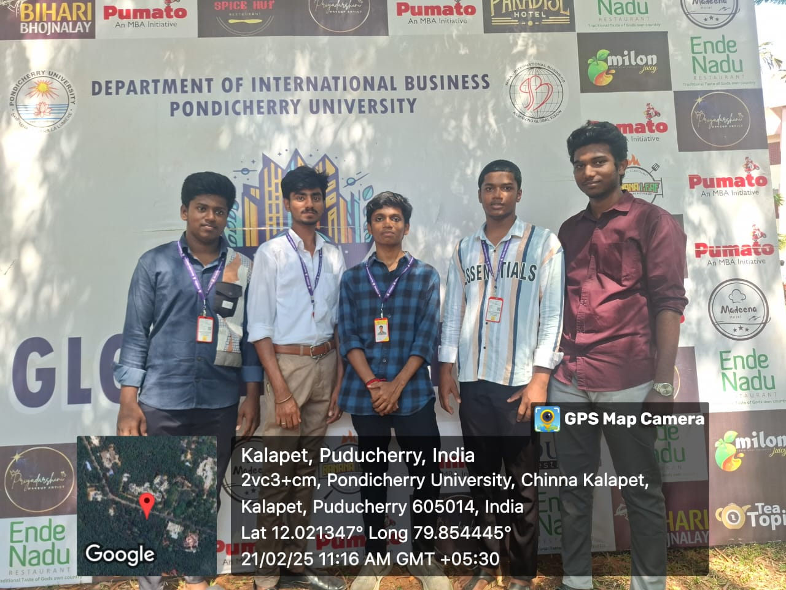

ST.JOSEPH ARTS AND SCIENCE COLLEGE-COMMET 2K25
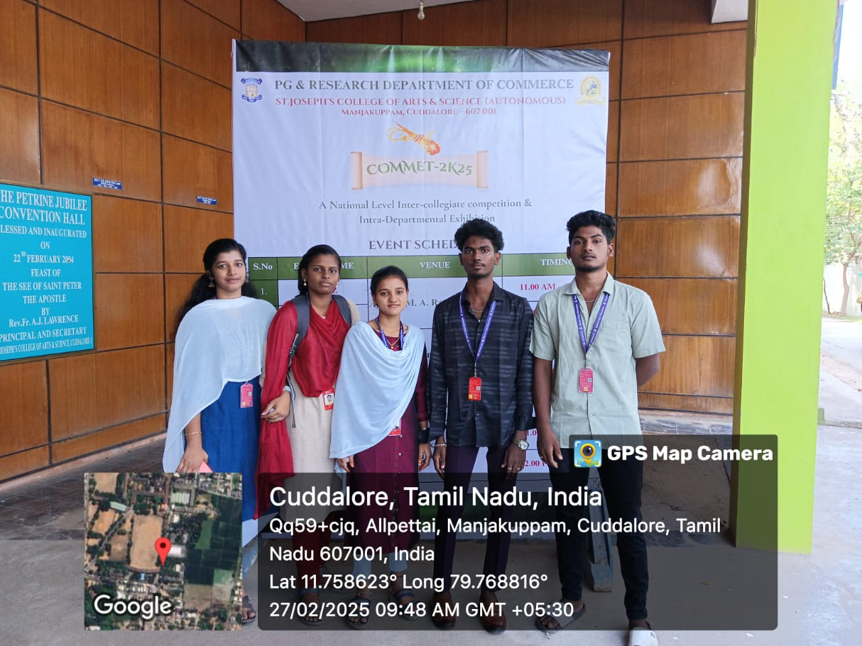
We are thrilled to announce that on February 27th, 2025, our Corporate Secretaryship students,, actively participated in the COMMET-2K25 organized by St.JOSEPH ARTS AND SCIENCE COLLEGE. We take great pride in their enthusiastic involvement and commendable achievements in the event.

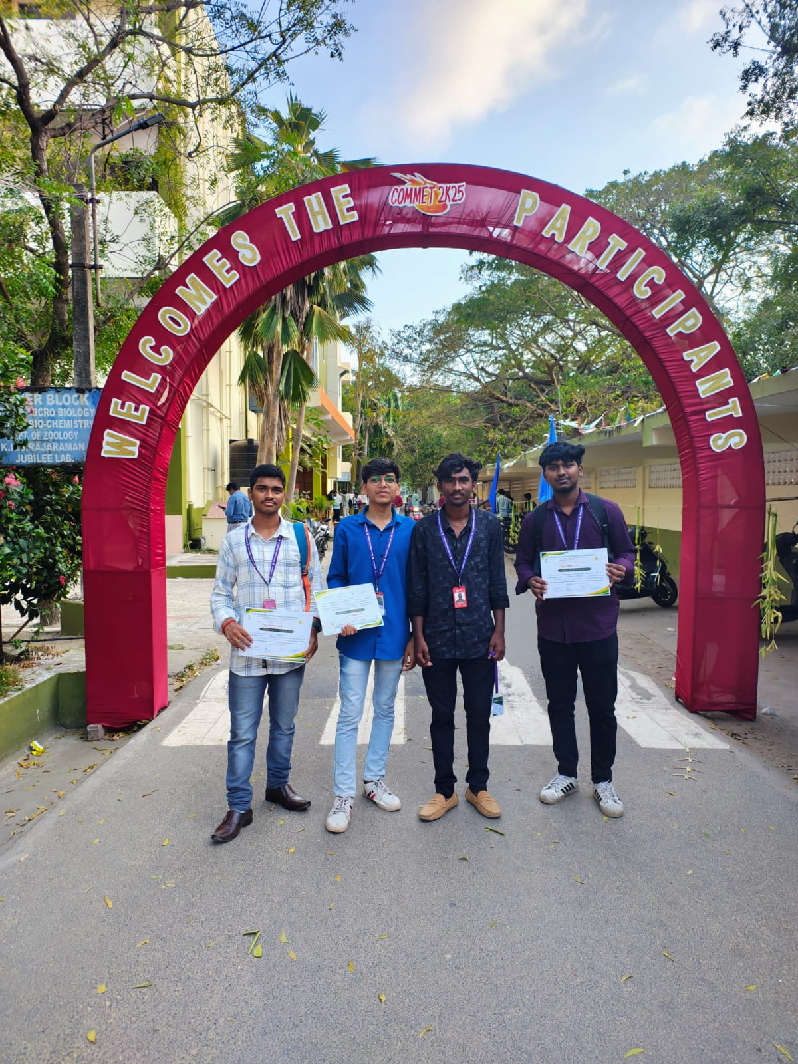

ST.ANN’S COLLEGE OF ARTS AND SCIENCE
We are thrilled to announce that on February 28th, 2025, our Corporate Secretaryship student, Bala Ganesh C, actively participated in the International Conference on Advanced Research in Computer Science and Applications, organized by St. Ann’s Arts and Science College. We take great pride in their enthusiastic involvement and commendable achievements in the event.
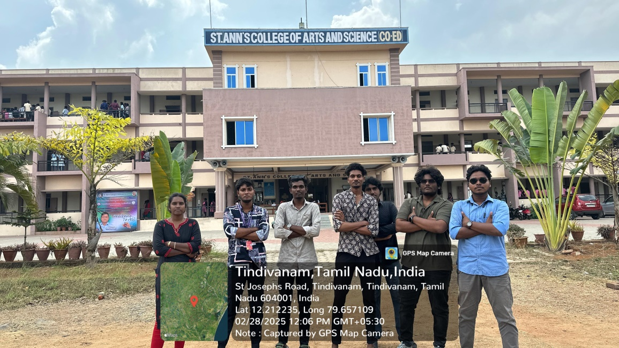
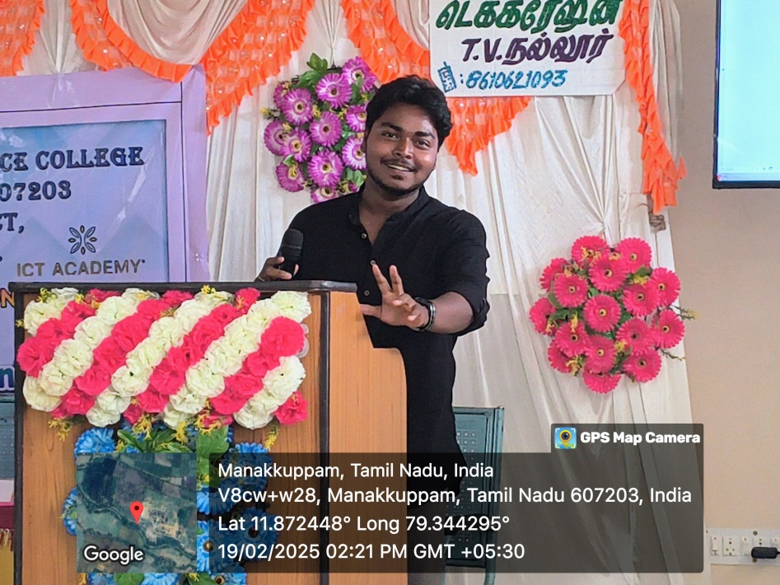

E.S ARTS AND SCIENCE COLLEGE
We are thrilled to announce that on March 3th, 2025, our Corporate Secretaryship student, HEMA , actively participated in the International Conference onInnovation and Sustainable Business Practices in the Digital Era, The Integration of ESC,AI &Modern Management Practices, organized by E.S Arts and Science College

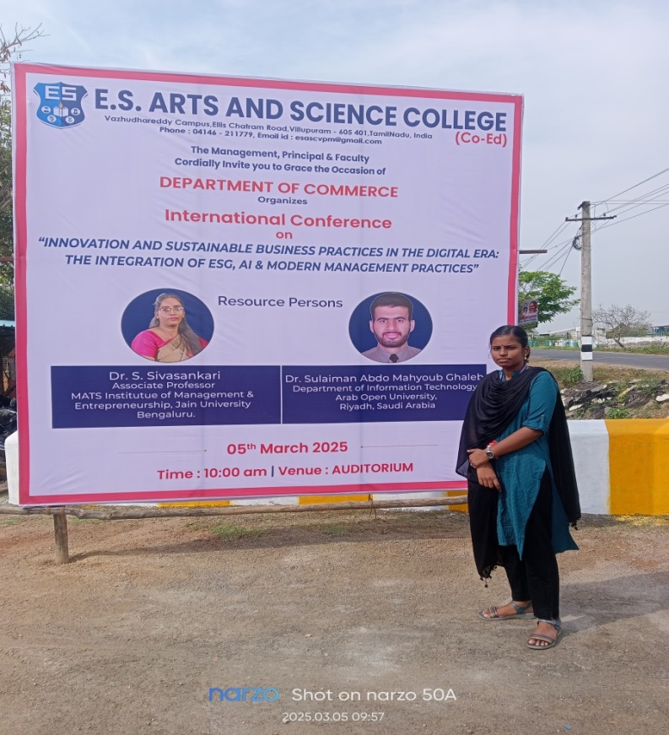

SARADHA GANGADHARAN COLLEGE
We are thrilled to announce that on30.4.2025, our Corporate Secretaryship student, HEMA , actively participated in the BIZFORTUNATE 2K25 organized by SARDAH GANGADHARAN COLLEGE

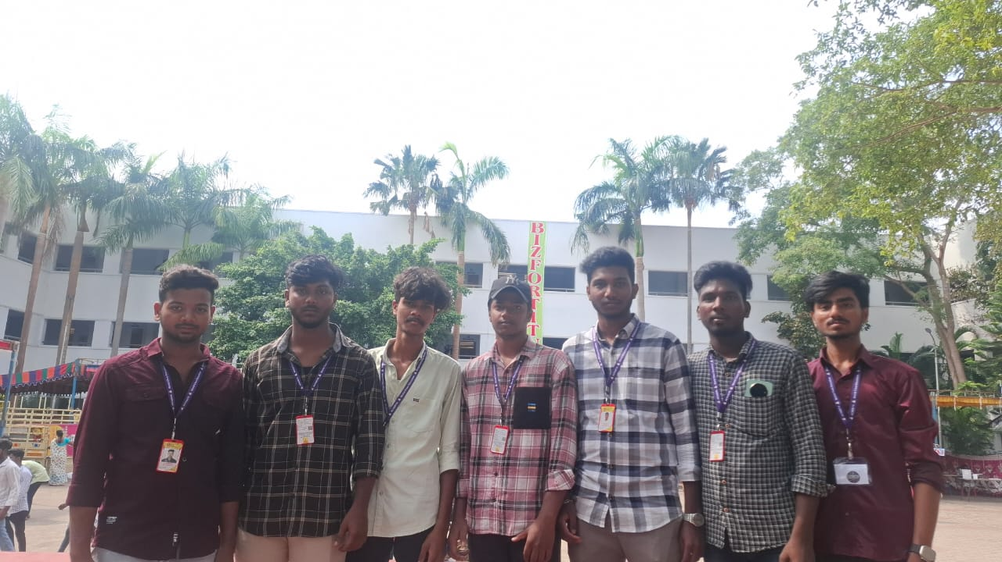

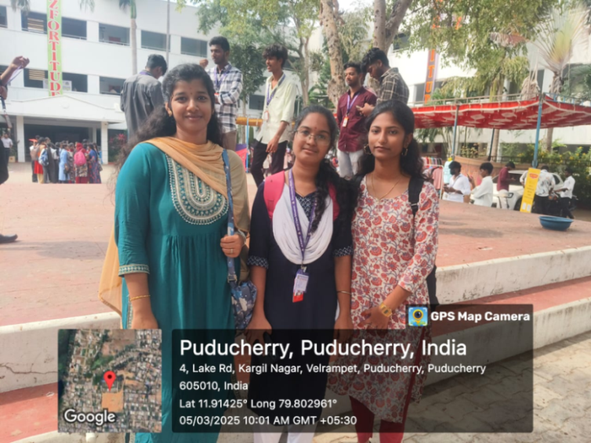



IDHAYA COLLEGE
Our B.com(CS) students actively participate at Idhaya college by displaying stalls to enrich their entrepreneurial capabilities
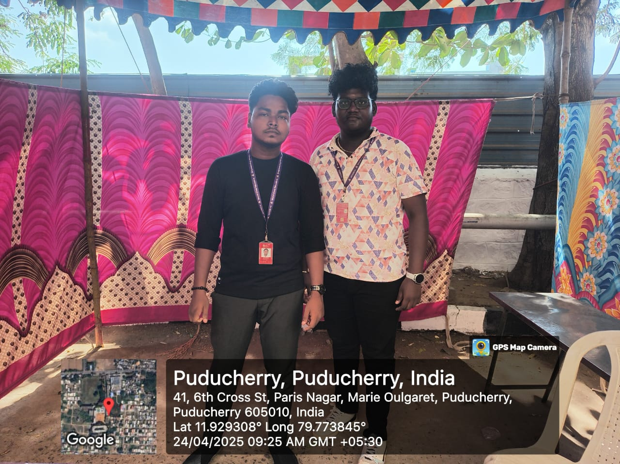

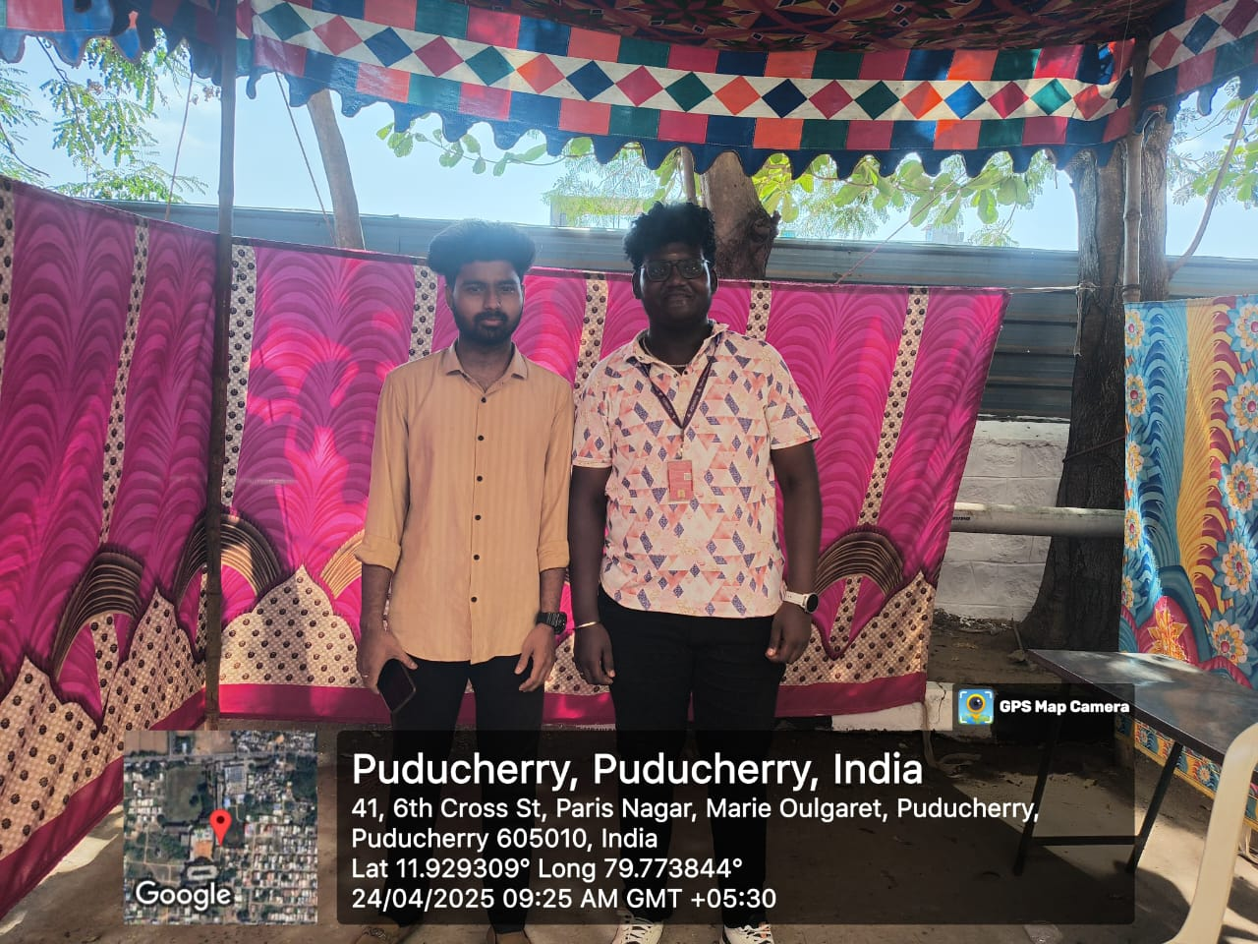

IDHAYA COLLEGE
We are proud to share that our students actively participated in the Inter-College Event 'Echelon 2K25', organized by the Department of Corporate Secretaryship, Idhaya College of Arts and Science for Women, Puducherry, held on 3rd May 2025.
A total of eight colleges took part in this vibrant event and we are thrilled to announce that our students won the overall championship trophy!
Winners from B.Com CS
(III Year):
M. Sharma Murugadhasan and C. Balaganesh – 1st Prize in Crisis Management
M. Sharma Murugadhasan and C. Balaganesh – 1st Prize in Brandswarts Battle
Deepak Prajapati B. – 1st Prize in Business Quiz
Winners from B.Com CS (II Year):
K. Akaash – 2nd Prize in Photography
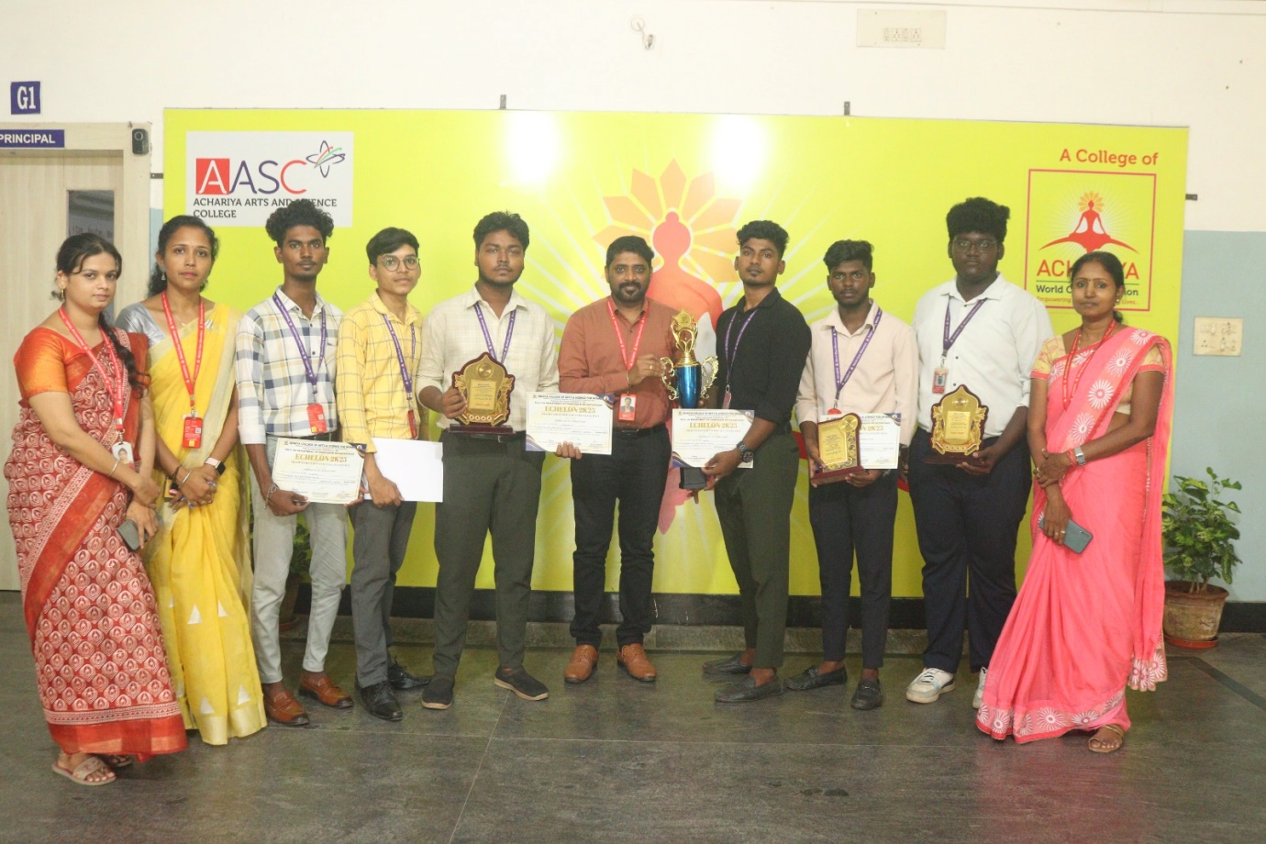

NATIONAL INSITUTE OF TECHNOLOGY-KARAIKAL
We are delighted to share on October 5th, 2024, our Commerce students Adarsh wins the second price in LECIEL 2K24, an event organized by National Insititute of Technology-Karaikal.

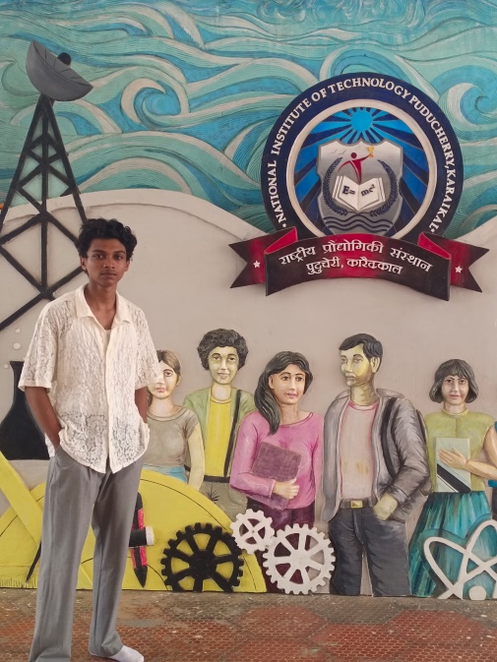

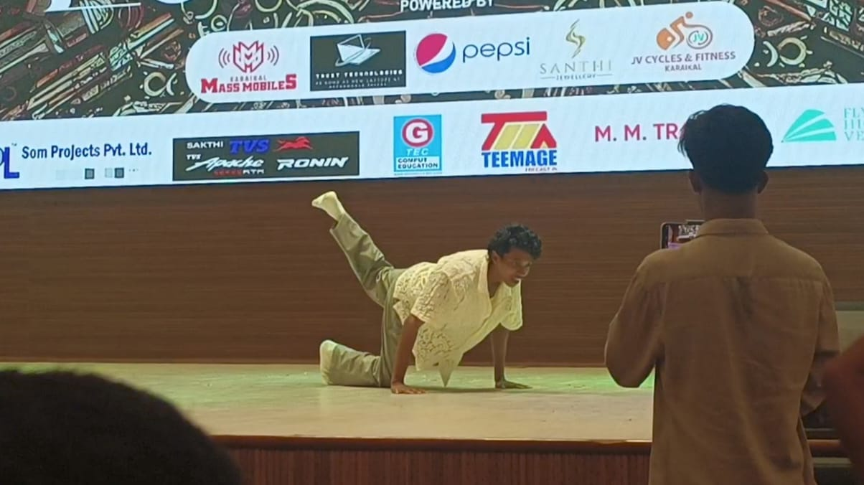

MANAKULA VINAYAR INSTITUTE OF TECHNOLOGY

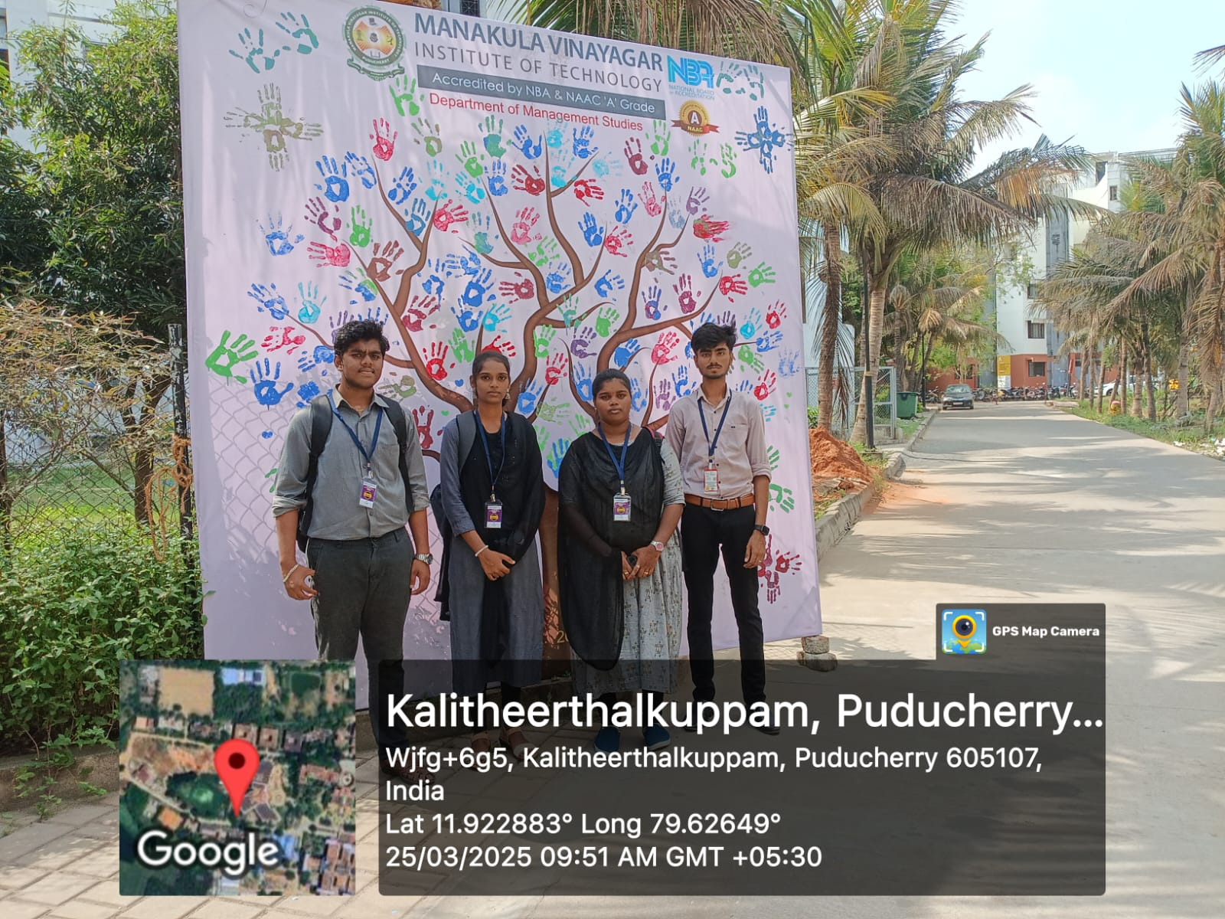
We are thrilled to announce that on30.4.2025, our Corporate Secretaryship student, HEMA , actively participated in events organized by Manakula Vinayagar institute of technology.

